**FSM (Finite State Machine)**  
From ManifoldInAction chapter 03: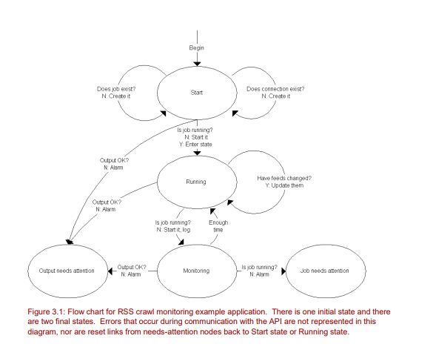  
  
*“…a finite state machine (FSM), that we can “program” to represent the states and transitions implied by our requirements. Better yet, since our application flow chart already looks a whole lot like a FSM, if we adopt the FSM approach we’ve already pretty much designed the application!”*For the code implementation, see *(from* [*https://github.com/DaddyWri/manifoldcfinaction*](https://github.com/DaddyWri/manifoldcfinaction)*):*

*manifoldcfinaction-master\manifoldcfinaction-master\examples\api_example  
  
  
Maybe see also:*[*http://community.wvu.edu/~hhammar/rts/adv%20rts/statecharts%20patterns%20papers%20and%20%20examples/yacoub-ammar%20fsm%20ch%2010.pdf*](http://community.wvu.edu/~hhammar/rts/adv%20rts/statecharts%20patterns%20papers%20and%20%20examples/yacoub-ammar%20fsm%20ch%2010.pdf)

*JeremyC 4-6-2018***END**